1. Enter https://www.mardep.gov.hk/en/home.html in browser (as below)
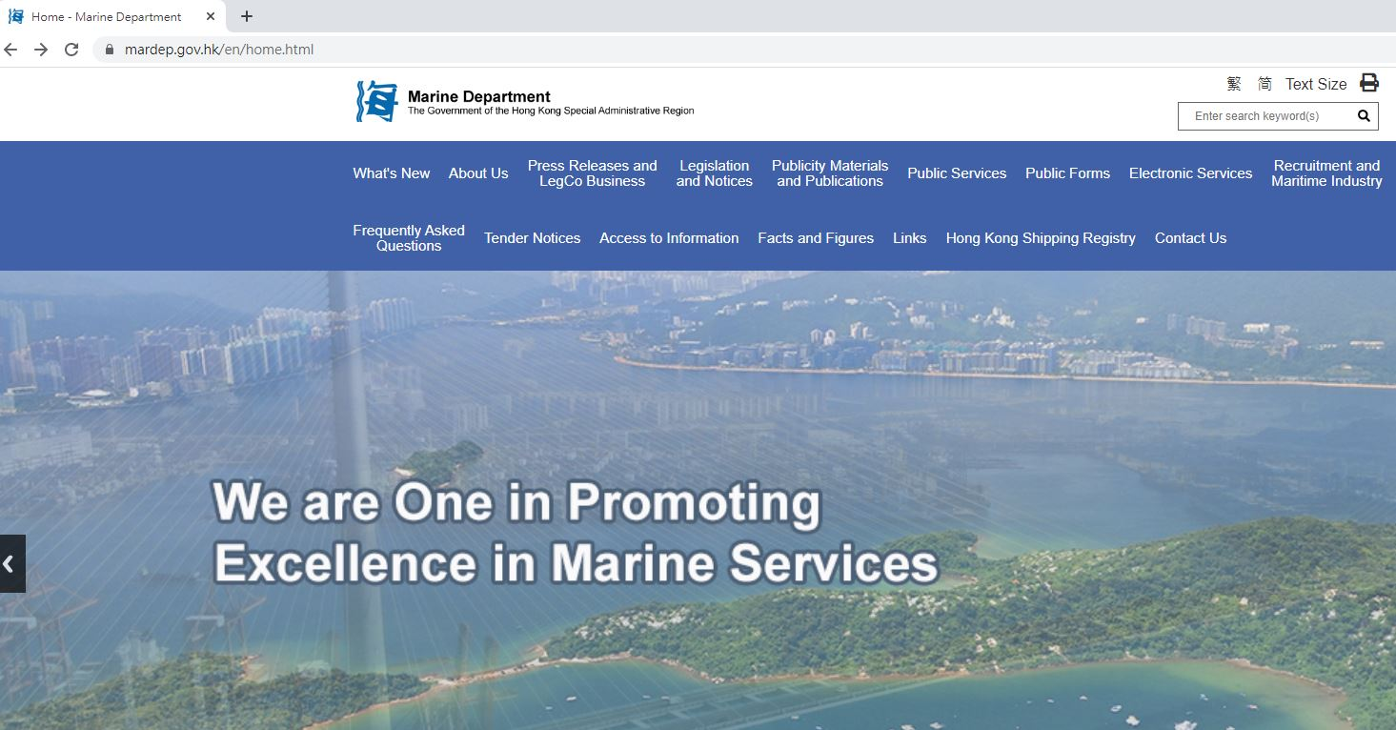
2. Click “Electronic Business System” under “Electronic Services”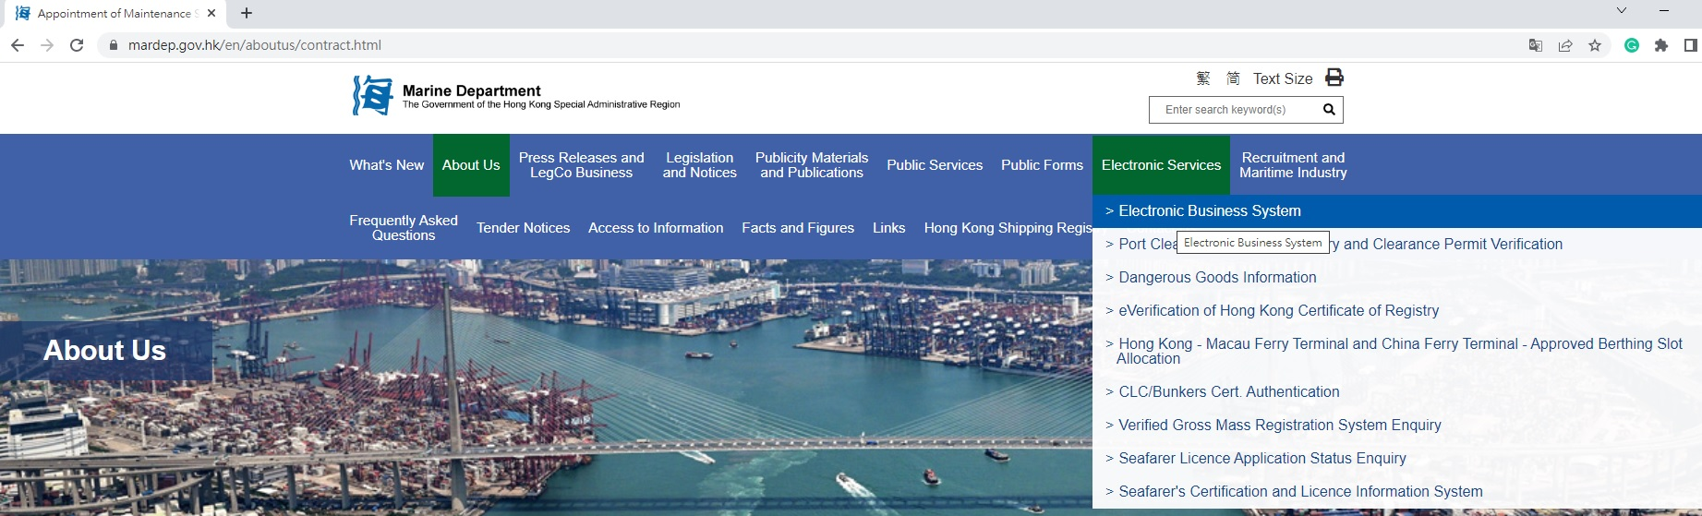3. Enter the website: https://ebs.mardep.gov.hk/en/index.php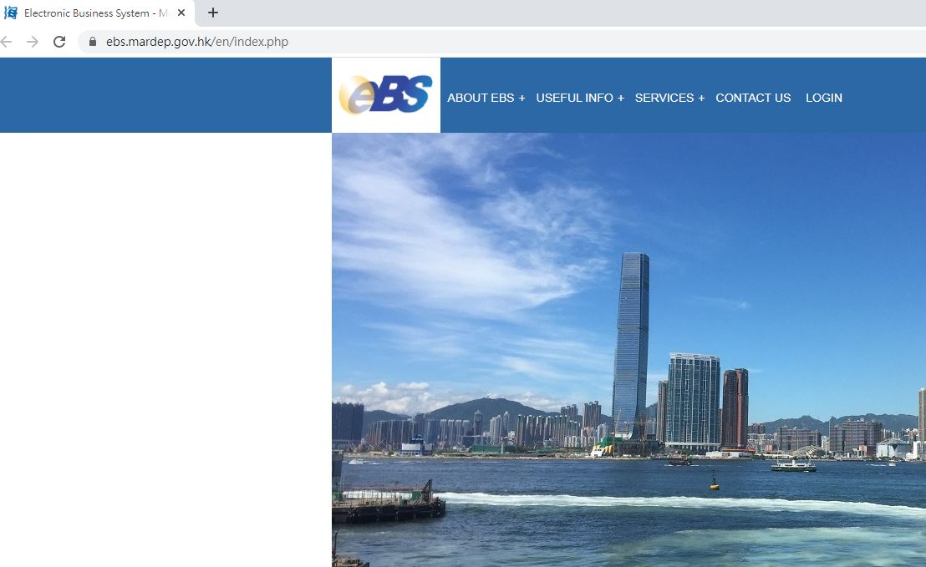
4. Click “Public Form Submission Services” under “SERVICES”
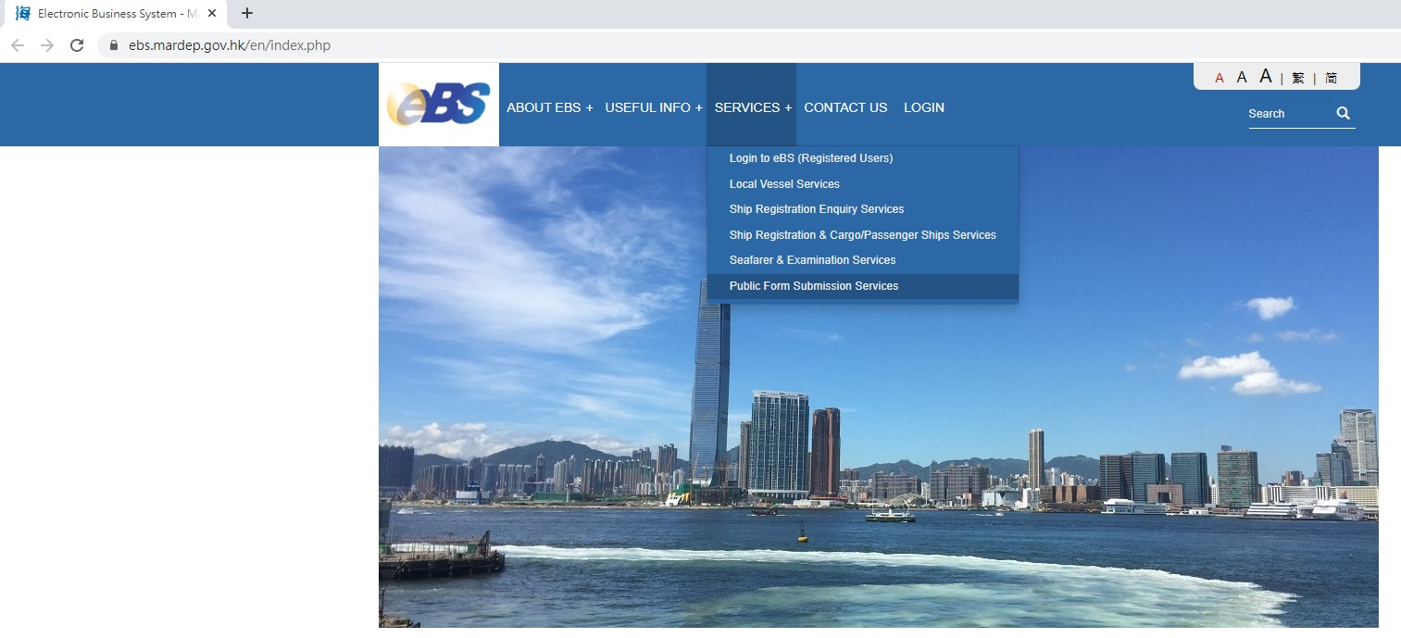
5. Enter token no. provided
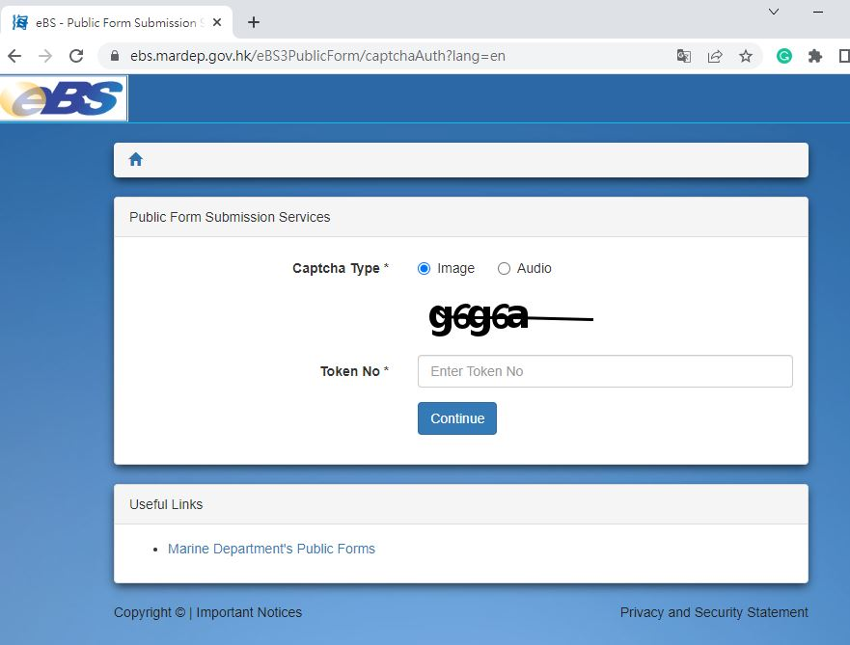

6. Select the desired form
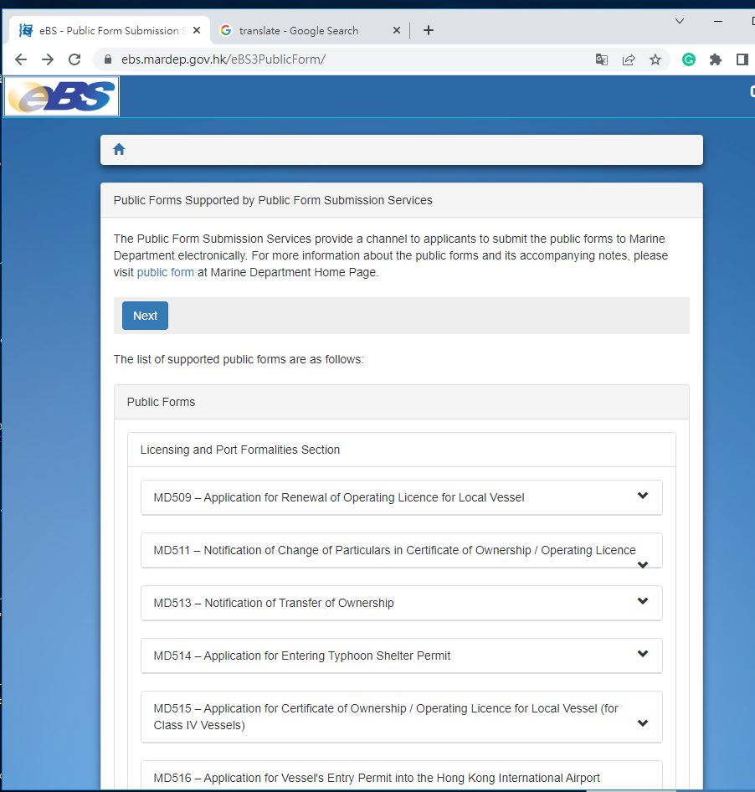
7. Example: download the fillable form and prepare the corresponding documents
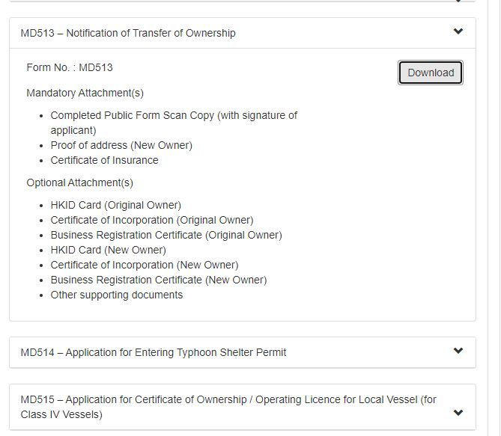

8. Click “Next”
9. Follow the instruction as below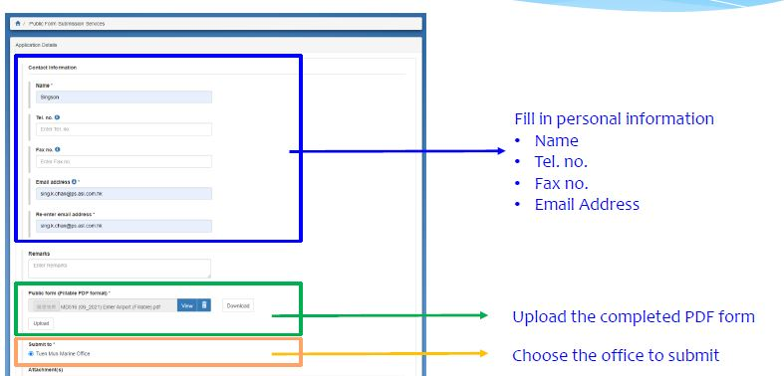
10. Choose appropriate office and upload the required documents as below
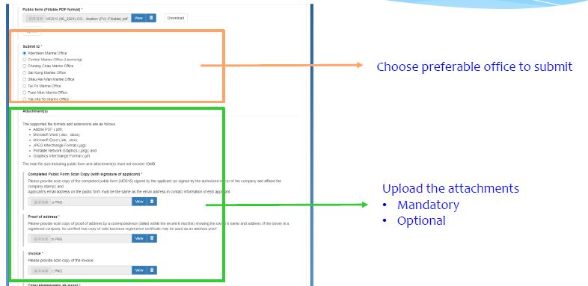

11. Received automatic reply and complete the submission
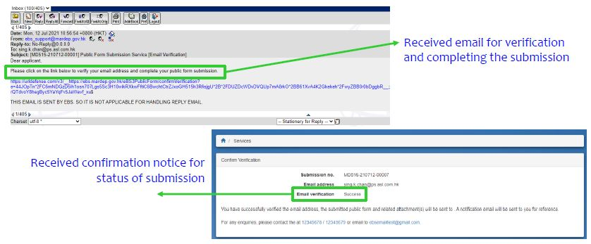
12. If failed to complete verification within 6 minutes, application should re-do the step 8 to 11.
